PROJECT PROPOSAL
STUDENT: Raphael Brown
STUDENT ID: 25101364
COURSE: Programming for Games & VFX Production
Proposed idea for a tool: Maya to Unreal LOD creator and exporter
I would like to create a plugin for Maya that generates and exports LODs for assets, and prepares them for exporting into Unreal Engine.
The purpose of the tool is to help speed up the asset creation process by automating repetitive tasks such as:
• Decimating the duplicated asset into 4 levels of detail (or more) objects
• Renaming the new LOD assets
• Setting pivot to centre and freezing the transformations of all objects
• Exporting the new FBXs with the correct settings
This tool is aimed at 3D artists who are looking to speed up the LOD creation process and improve the efficiency of the pre-existing method in Maya.
I believe the tool will benefit teams of game developers the most, since they are known to work under strict deadlines and are generally looking to streamline their pipelines as much as possible.
The completed plugin will be accompanied by a User Guide with instructions on how to install and use the tool.
My plan:
- Create tool in Python for the Maya API using a PySide GUI (Qt)
- Connect to Maya and ensure functionality
- Create GUI for Maya UI
- If there is time, make an automatic export button to send exported FBX to Unreal
The proto version of this tool should be able to:
- Generate LODs
- Rename correctly (LOD0, LOD1…)
- Decimate them with controls for achieving the desired result
- Make sure each LOD inherits the exact materials from the original mesh
- Set pivot / freeze transforms
- Export FBX with correct settings
- Import manually into Unreal
After the stable version is finished, additional utilities can be added to upgrade the plugin so that it can:
- Troubleshoot mesh in order to detect non-manifold geometry and other errors
- Export new LOD mesh strait into Unreal with a click of a button
- Create Generate LODs for multiple assets at once
- Batch Export to Unreal
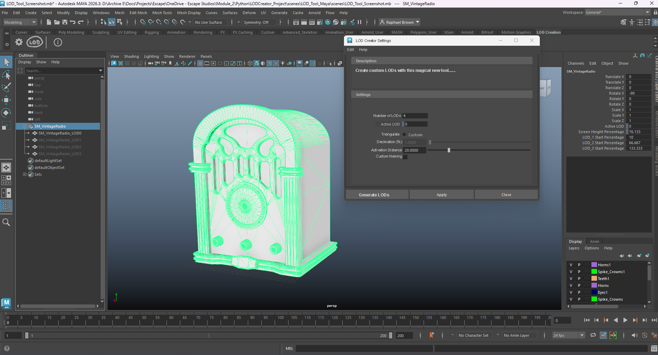
UX/UI mock-up:

1- Tab for tool 2- Tab buttons 3- Window for tool setting controls

